- Complete the table for the following quadratic relations:
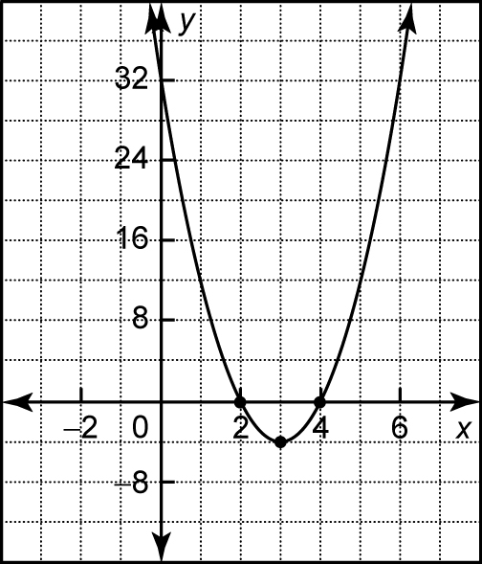
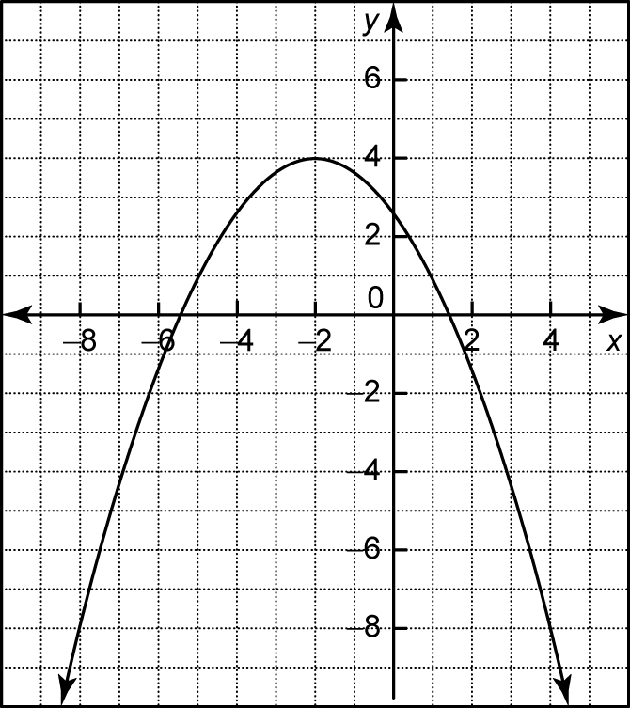
a) b)

Quadratic Relation | Vertex | Axis  of symmetry | Minimum/ maximum value
a)
b)

2. Complete the following chart .

Equation | Vertex  (h, k) | Axis Of Symmetry (x = h) | Max/Min Point (y= k) | Shift  (Dir. & Amt.) | Stretch/  Compression
y = - 3(x+5)² +4

- Describe the transformations applied to the graph of $y=x^{2}$ to obtain the graph of $y=-\frac{1}{4}{(x-2)}^{2}-3$.

How well did you understand the lesson? (circle one)
I don’t understand!
I understand some of it!!
I understand!

