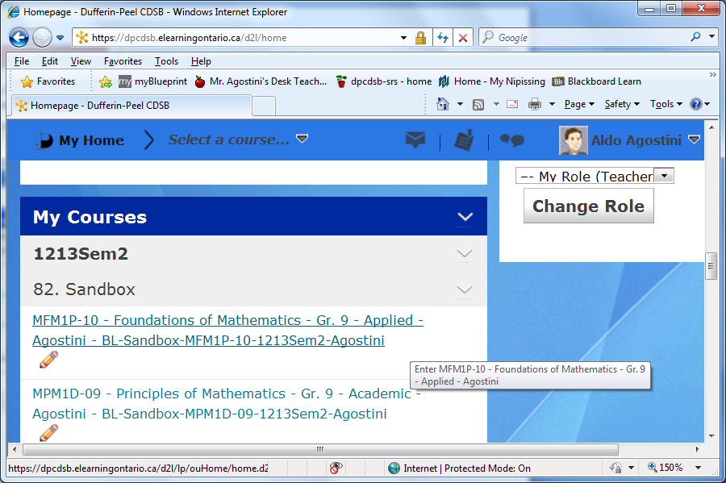
Step 1: In today’s activity we will add students to our class. From the D2L home page, click on the course you wish to add students to.
Course content shown here.
Course name should appear here.
Click on the course you want to select.

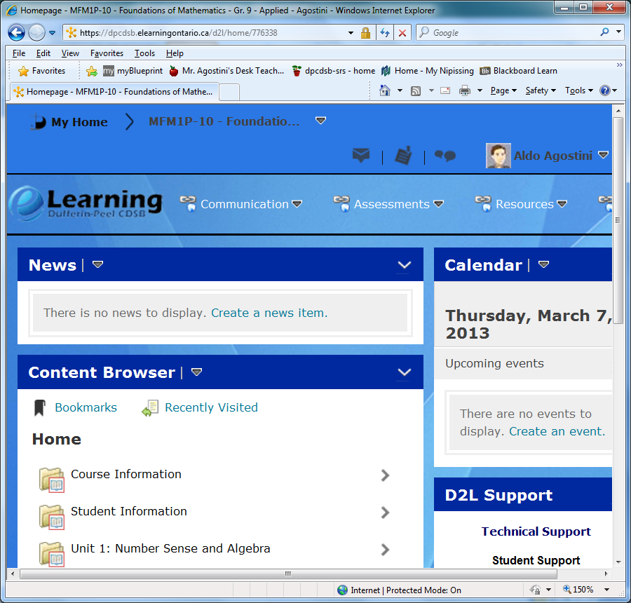
Step 2: This will make the course active, it should display in the top of the menu bar, furthermore, those courses with content will display the content in the content window pane.

Step 3: To enter student names, select the down arrow beside the word COMMUNICATION:
5. Click on Add Participants.
4. Pick Classlist.
3. Click on down arrow and menu appears. ;0)
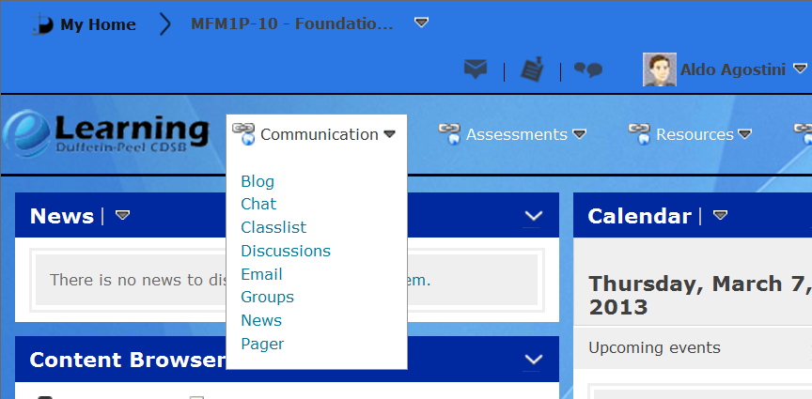
Step 4: Select Classlist from the options.
Step 5: Click on the Add Participants and select
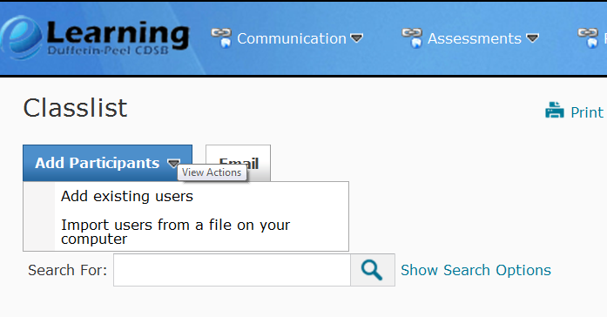
5. Select Add existing users

Step 6: Type in the student number in the Search For then click on the Magnifying glass to start your search.
Select _Student as a role.
After typing in the student number click the magnifying glass to start your search.
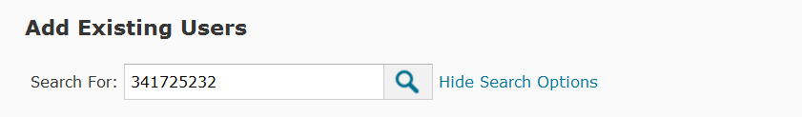
Step 7: Once the search is complete, the student name should appear at the bottom of your screen.
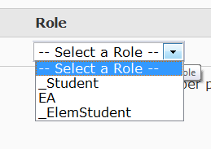
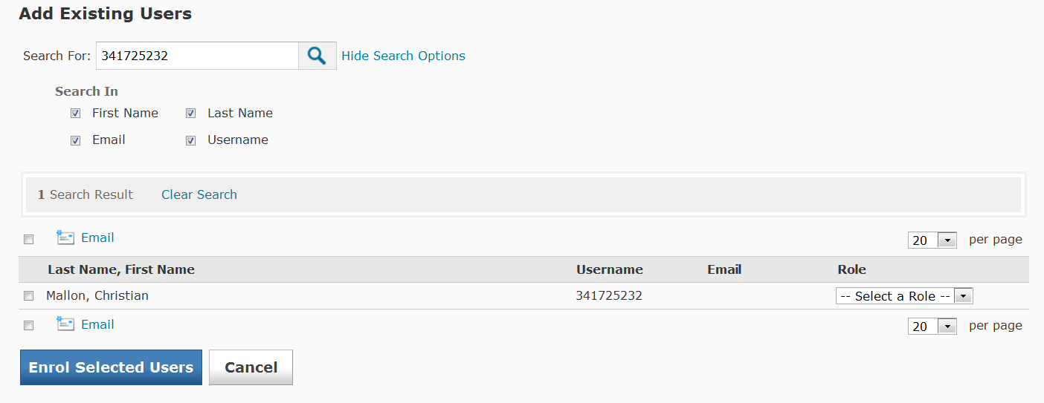
Step 8: Check the CHECKBOX beside the student name (if this is the correct student) and select the ROLE of the student as _Student As depicted below.

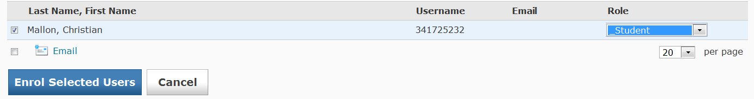
Step 9: Click Enrol Selected Users
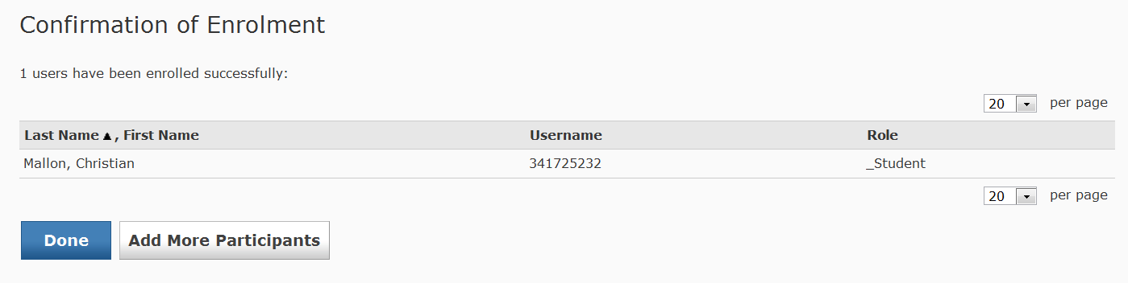
Step 10 : A Confirmation of Enrolment will appear. To add another student, click on Add More Participants. If your Done adding, click on DONE.

Step 11: If you are adding more students, follow the steps above for each student in your class. If your DONE, you will see your class listed below:
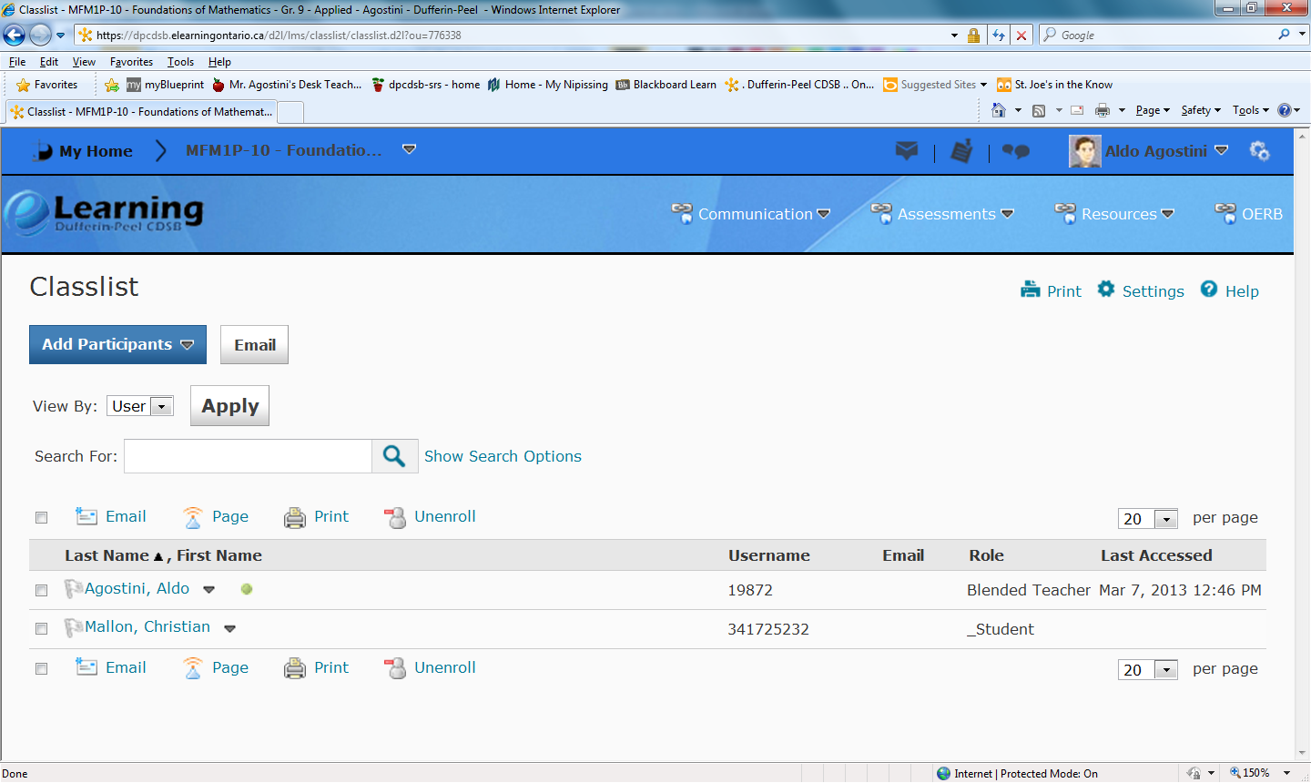
This is the most basic way of enrolling students into your blended learning class.

